Shapefile label operations Tutorial (7)

  - Tutorial (7)
Purpose of this tutorial:
1. Create a label to the shape file from its attribute table column. User can select any attribute from shape file's attribute table.
2. Add a custom label to the shape files via user input. User can type any name in the text box and select the shape to set the label.
3. Change the label appearance.
Step 1: Add the DotSpatial reference and change the compile option.
Add the following references:
DotSpatial.Data.Forms.dll, DotSpatial.Symbology.dll, DotSpatial.Controls.dll, DotSpatial.Projections.dll, DotSpatial.Data.dll, DotSpatial.Topology.dll
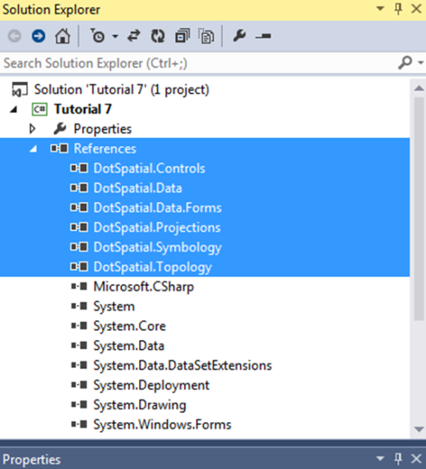
Figure 1: Required dlls
Step 2: Add the DotSpatial controls on the Visual Studio Toolbox window.
If you don't have DotSpatial control tab, create a new tab on the toolbox and add the DotSpatial controls to it, the same as the first tutorial.
Step 3: Design the Graphical user interface
Design the GUI as follows:
Add a menu strip control and design the menu items as follows:
Main menu items:
File, Map Options.
Sub menu items:
File menu has the following sub menu items:
Load, Clear and Exit
Map Options menu item has the following sub menu items:
Zoom In, Zoom Out, Zoom to MaxExtent, Pan, and Default.
Add a SpatialDockManager and set the properties as follows:
Name: sdmOperationsMap, Dock: Fill, BorderStyle: FixedSingle
Add a FontDialog box and ColorDialog box. Both dialog boxes are located on the tool box under the AllWindowsForms tab.
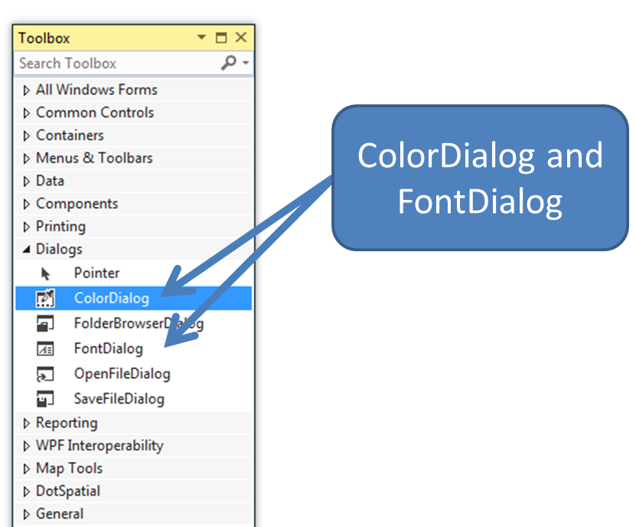
Figure 2: ColorDialog and FontDialog
Add a map control into the right SpatialDockManger panel and set its properties as follows:
Dock : Fill
Add three Groupboxes and set those properties as follows:
Properties | Groupbox1 |  | Groupbox2 | Groupbox3
Name |  | gbCustom | gbShapeAttribute | gbCustomAttribute
Text |  | Set the label properties | Display label from Attribute table | Custom Attributes for existing shape file

Add 2 buttons into the gbCustom group box and set those buttons properties as follows:
Name : btnsetFont Text : Set Font Style and Size
Name : btnsetColor Text: Set Color
Add the following controls into the gbShapeAttribute group box.
Add a label control and set its properties as follows:
Name : lblFieldName Text: Fields
Add a comboBox and set its properties as follows:
Name: cmbFiledName
Add a button and set its properties as follows:
Name : btnDisplayLabel Text : Display Labels
Add the following controls into the gbCustomAttribute group box.
Add a label control and set its properties as follows:
Name : lblLabelName Text: Label name
Add a text box and set its properties as follows:
Name: txtCustomAttribute
Add 3 buttons and set those properties as follows:
Properties | Button1 | Button2 |  | Button3
Name | btnAdd |  | btnSave |  | btnDelete
Text | Add |  | Save |  | Delete

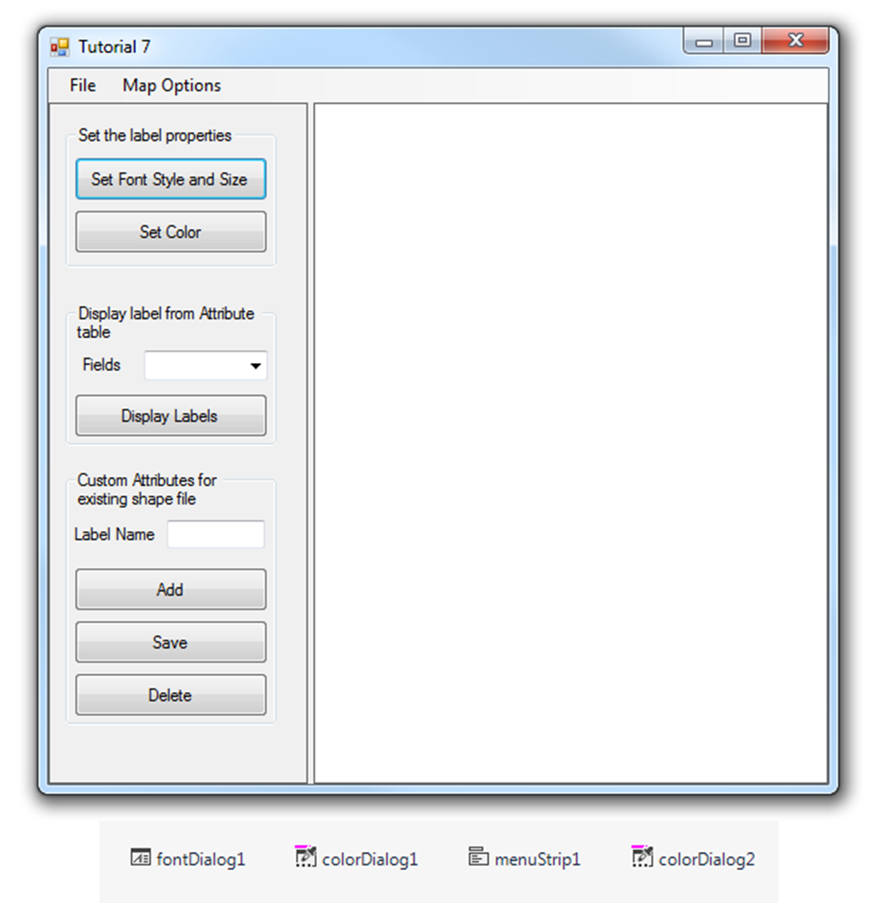
Figure 3: Final User Interface

Step 4: Code implementation
using DotSpatial.Data;
Write the following code in the Load menu item click event.
private void loadToolStripMenuItem_Click(object sender, EventArgs e)
{
//Clear the existing layers from the map control
if ((map1.Layers.Count > 0))
{
map1.Layers.Clear();
}
//Clear the existing items from the combobox
cmbFiledName.Items.Clear();

//add the layers
OpenFileDialog fileDialog = new OpenFileDialog();
fileDialog.Filter = "Shapefiles|*.shp";
if (fileDialog.ShowDialog() == DialogResult.OK)
{
//add layer to first map
IFeatureSet featureSet1 = FeatureSet.Open(fileDialog.FileName);
//FillColumnNames method is used to get all the attribute column names
//Based on the names combobox will be populated
FillColumnNames(featureSet1);

featureSet1.Reproject(map1.Projection);

map1.Layers.Add(featureSet1);
map1.ZoomToMaxExtent();
}
}

4.2 ) FillColumnNames method.
/// <summary>
/// This method is used to populate the attribute names from the shape file into the combobox
/// </summary>
/// <param name="featureSet"></param>
/// <remarks></remarks>
///
private void FillColumnNames(IFeatureSet featureSet)
{
foreach (DataColumn column in featureSet.DataTable.Columns)
{
cmbFiledName.Items.Add(column.ColumnName);
}
}

Display the label on the shape file from its attribute table.
Declare the following class level variables.
string fname = "Tahoma";
double fsize = 8.0;
Color fcolor = Color.Black;

Write the following code into the btnDisplayLabel_Click event.
private void btnDisplayLabel_Click(object sender, EventArgs e)
{

if ((cmbFiledName.Text == string.Empty))
{
MessageBox.Show("Please select an attribute from the textbox");
}
else
{
DisplayLabels(cmbFiledName.Text.ToString());
}
}

DisplayLabels method code.
/// <summary>
/// This method is used to display a lebel on a shape file base on user selection from combobox
/// </summary>
/// <param name="attributename">Attribute name</param>
/// <remarks></remarks>
private void DisplayLabels(string attributename)
{
//Check the number of layers from MapControl
if (map1.Layers.Count > 0)
{
map1.AddLabels((DotSpatial.Symbology.FeatureLayer)map1.Layers[0], "[" + attributename + "]", new Font("" + fname + "", (float)fsize), fcolor);
}
else
{
MessageBox.Show("Please add a layer to the map.");
}
}

Display a custom label
Write the following code btnAdd_Click event.

private void btnAdd_Click(object sender, EventArgs e)
{
DisplayCustomLabel(txtCustomAttribute.Text);
txtCustomAttribute.Text = "";
}

DisplayCustomLabel method code.
private void DisplayCustomLabel(string attributeValue)
{
if (string.IsNullOrEmpty(txtCustomAttribute.Text))
{
MessageBox.Show("Please enter the label text");
return;
}

IMapFeatureLayer selectedLayer = (IMapFeatureLayer)map1.Layers[0];
if (selectedLayer == null)
{
MessageBox.Show("Please add a layer to the map");
return;
}

int numSelectedFeatures = selectedLayer.Selection.Count;
if (numSelectedFeatures == 0)
{
MessageBox.Show("Please select a shape in the map");
return;
}

//create new column in attribute table
DataTable table = selectedLayer.DataSet.DataTable;

if (!(table.Columns.Contains("new_label")))
{
table.Columns.Add(new DataColumn("new_label"));
}

List<IFeature> selectedFeatureList = selectedLayer.Selection.ToFeatureList();
IFeature selectedFeature = selectedFeatureList[0];

selectedFeature.DataRow["new_label"] = txtCustomAttribute.Text;

//display labels in the map
map1.AddLabels(selectedLayer, "[new_label]", new Font("" + fname + "", (float)fsize), fcolor);

//reset map selection mode
map1.FunctionMode = FunctionMode.None;
}

Write the following code into the txtCustomAttribute_TextChanged event.
private void txtCustomAttribute_TextChanged_1(object sender, EventArgs e)
{
map1.FunctionMode = FunctionMode.Select;
}

Write the following code into the btnSave_Click event.
private void btnSave_Click(object sender, EventArgs e)
{

if (map1.Layers.Count > 0)
{
IMapFeatureLayer stateLayer = default(IMapFeatureLayer);
stateLayer = (IMapFeatureLayer)map1.Layers[0];
stateLayer.DataSet.Save();
MessageBox.Show("Attribute has been saved in the shapefile.");
}
else
{
MessageBox.Show("Please add a layer to the map.");
}
}

Write the following code into the btnDelete_Click event.
private void btnDelete_Click(object sender, EventArgs e)
{

//Declare a datatable
DataTable dt = null;
if (map1.Layers.Count > 0)
{
IMapFeatureLayer stateLayer = default(IMapFeatureLayer);
stateLayer = (IMapFeatureLayer)map1.Layers[0];
//Get the shapefile's attribute table to our datatable dt
dt = stateLayer.DataSet.DataTable;
//Remove a column
dt.Columns.Remove("new_label");
stateLayer.DataSet.Save();
MessageBox.Show("Attribute has been removed in the shapefile.");
}
else
{
MessageBox.Show("Please add a layer to the map.");
}
}

Set label properties.
Set the font.
Write the following code into the btnsetFont_Click event.
private void btnSetFont_Click(object sender, EventArgs e)
{

if (fontDialog1.ShowDialog() == System.Windows.Forms.DialogResult.OK)
{
fname = fontDialog1.Font.Name;
fsize = fontDialog1.Font.Size;
}
}

Set the font color.
Write the following code into the btnsetColor_Click event.
private void btnsetColor_Click(object sender, EventArgs e)
{
if (this.colorDialog1.ShowDialog() == DialogResult.OK)
{
fcolor = colorDialog1.Color;
}
}

Menu strip controls code.
Menu item s code.
private void clearToolStripMenuItem_Click(object sender, EventArgs e)
{
map1.Layers.Clear();
}

private void exitToolStripMenuItem_Click(object sender, EventArgs e)
{
this.Close();
}

private void zoomInToolStripMenuItem_Click(object sender, EventArgs e)
{
map1.ZoomIn();
}

private void zoomOutToolStripMenuItem_Click(object sender, EventArgs e)
{
map1.ZoomOut();
}

private void zoomToExtentToolStripMenuItem_Click(object sender, EventArgs e)
{
map1.ZoomToMaxExtent();
}

private void panToolStripMenuItem_Click(object sender, EventArgs e)
{
map1.FunctionMode = FunctionMode.Pan;
}

private void measureToolStripMenuItem_Click(object sender, EventArgs e)
{
map1.FunctionMode = FunctionMode.Measure;
}

private void defaultToolStripMenuItem_Click(object sender, EventArgs e)
{
map1.FunctionMode = FunctionMode.None;
}
Output screen shot
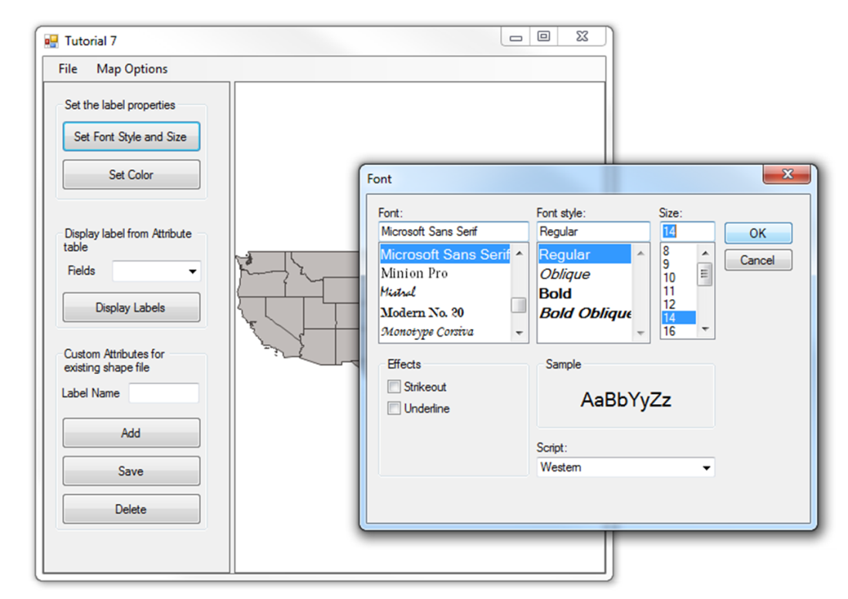
Figure 4: Set the Label Font Style and Size

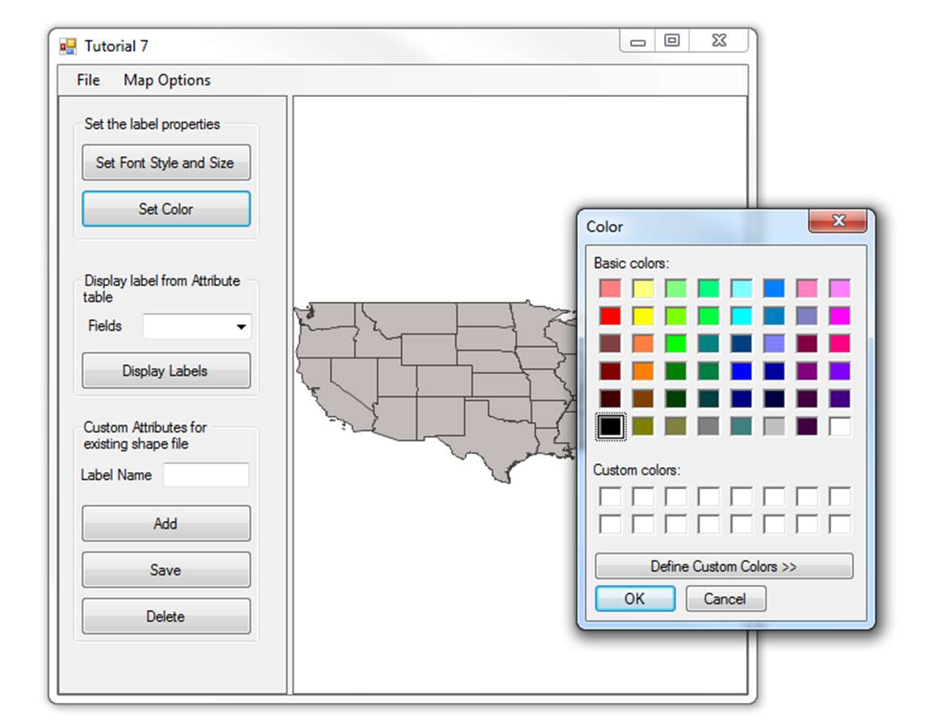
Figure 5: Set the Label Font Color
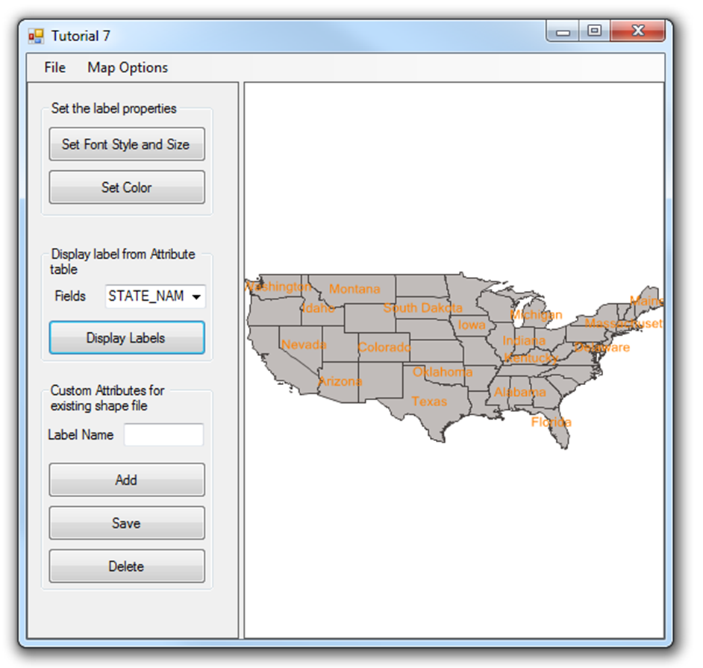
Figure 6: Displaying the Label
Be sure to click Display Labels each time you change the label’s properties in order to refresh the labels on the map.
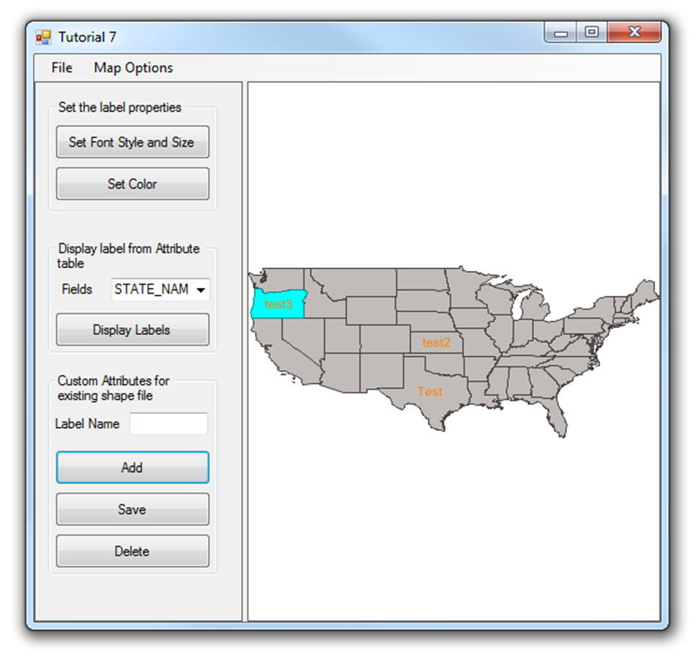
Figure 7: Create a Custom Label

